Press release
December 23^{d} 2015

Veolia Ukraine subsidiary in Ternopil celebrates its 20th anniversary
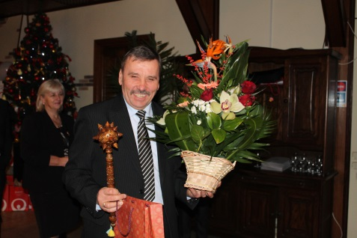 |  | 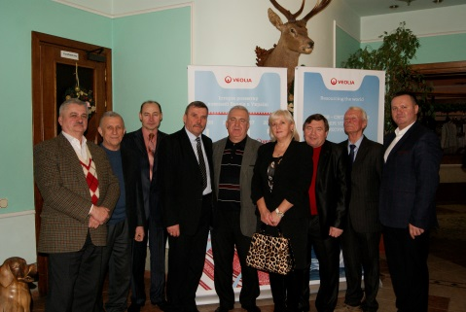 |  | 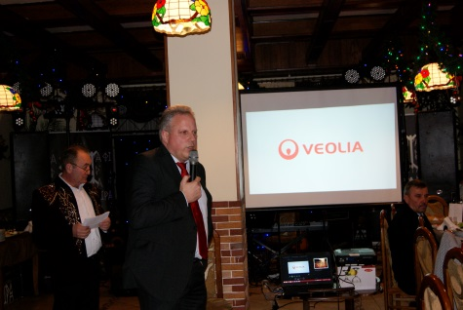

On December 18th Veolia subsidiary in Ternopil, Altvater Ternopil company celebrated its 20th anniversary in Ukraine. This outstanding event welcomed the representatives of Ternopil City Council, Heads of communal services, business representatives of the region, partners of the company and Top management of Veolia Ukraine as well, Matthias Vogel, Head of Ukraine region, Alexander Dorscht, Technical Director for Veolia Ukraine and Alexander Korolyuk, Managing Director for Ukraine.

Veolia Ukraine company begins its countdown in 1995 in Ternopil region. For 20 years Altvater Ternopil subsidiary has experienced many events. The company managed to survive in a very tough time, expand its business activities and strengthen its position as an industry leader, providing the entire spectrum of environmental services in the waste management area.

«The celebration of twenty-year anniversary is a significant event for us, said Vasyl Ordenas, Altvater Ternopil Site Manager, demonstrating the trust and appreciation of our commitments by Ternopil residents. We intend to develop further our activities, to become more agile and more efficient for our customers and move forward with the modern world.

«Today is an important milestone for our subsidiary company in Ternopil, noted Matthias Vogel, Head of Ukraine region. It is a history of victories, challenges and invaluable experience. I am exceptionally proud of what we have achieved and I am convinced the initiatives we are putting in place in the waste management area will accelerate the deployment of a profitable growth in Ternopil region and throughout Ukraine as well.

"I am particularly impressed by the enthusiasm, commitment and knowledge of all the staff of Veolia subsidiary in Ternopil, - said Alexander Korolyuk, Managing Director of Veolia Ukraine. Tonight we are witnessing the fruits of 20 years on a journey of passionate work, continuous learning and talent development. I wish you to move confidently forward to the next anniversary, adding new achievements and accomplishment to your treasury».

********************************************************************************************************************************

Veolia has been operating in Ukraine since 1995 in the waste management area which represents a core business line on the local market. Today Veolia Ukraine is managing activities through four subsidiaries located in Kyiv, Ternopil, Chernivtsi and Yalta. The company has achieved ISO 9001:2008 certification for all its sites across Ukraine.

For any additional information please consult the web-site www.veolia.ua.

...

Contact
Olga Nikulina
Tel. : + 38 (095) 272 23 58
olga.nikulina@veolia.com

