Press release
Kyiv, 14th September, 2020
Veolia and Nestle launch a Project on Separate Collection and Processing of Recyclables

September 14, 2020 — Veolia and Nestlé announce the launch of a project on separate collection of recyclables in three towns near Kyiv – Makariv, Novi Petrivtsi and Stari Petrivtsi, with the total population of about 28 thousand people. The companies joined their forces and will invest UAH 57 mln in five years to build the infrastructure for collection and processing of over 40 tons of recyclables per month in these three towns of Kyiv region.

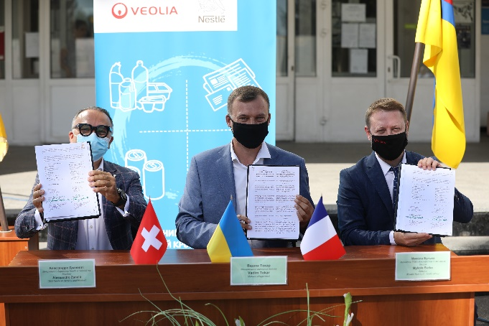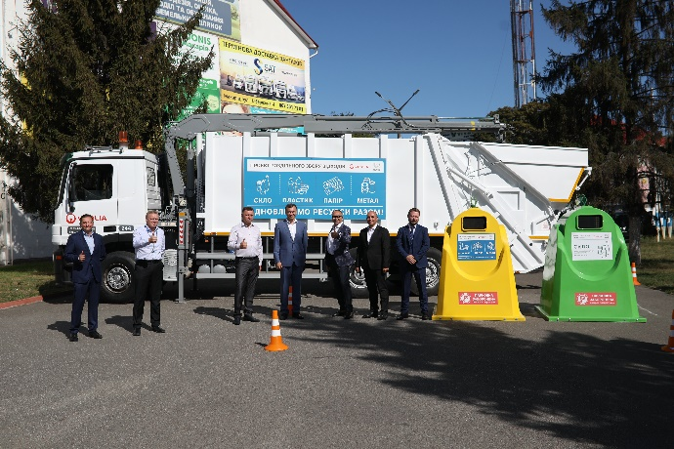

Supporting the target of developing a circular economy, the goal of the project is to develop an industrial standard for the collection and processing of recyclables as early as possible. The project will pave the way towards the principle of Extended Producer Responsibility (EPR) – which is so far not implemented in Ukraine - taking into account the “polluter pays principle” and placing the responsibility for returning and recycling of packaging waste on the producer.

This project marks a very important change of behavior requiring the collaboration of all stakeholders. This is why Veolia and Nestlé with the support of local authorities of Makariv, Novi Petrivtsi and Stari Petrivtsi, are creating an infrastructure and a system for the collection, sorting and processing of packaging waste.

As a part of the initiative and preparation of towns infrastructure for project launch, it is planned to establish over 200 specialized containers for collecting paper, metal, glass, and plastic, that will allow collecting about 20 tons of glass and 25 tons of other types of recyclables a month. All the collected wastes will be recycled in order to reduce waste generation at local communities.

Partnership between Veolia and Nestle is planned for five years and is a part of creating shared values initiative, aimed at minimization of impact on the environment and creation of shared value for the society and the company.

